Stage 4: Spread to Distant Organs
Stage 4 prostate cancer has spread beyond the prostate and nearby tissues to distant organs such as bones, liver, or lungs. PSA levels are typically elevated, and symptoms may become more noticeable.
This stage is considered advanced or metastatic. Treatment focuses on controlling cancer growth, managing symptoms, and maintaining quality of life.
What to expect: bone pain, urinary issues, fatigue, and discussions about systemic therapies including hormone therapy, chemotherapy, or clinical trials.
What to do: follow your oncologist’s advice, consider supportive care, maintain healthy habits, and connect with patient support services.
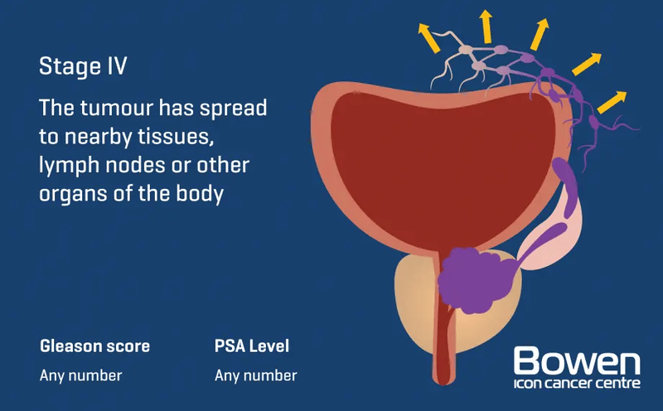
Image source: Bowen Icon Cancer Centre
Stage 4 emphasizes the importance of ongoing care and support. Men and whānau are encouraged to stay informed, ask questions, and access all available resources.

